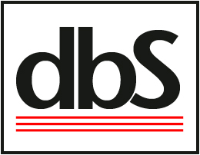
dbS Productions
Search and Rescue Program
Lost Person Behavior (LPB)

Please indicate your preference for workshop subject category topics by placing a 1, 2, 3, in the blanks below. If you have a 4th and 5th preference as well you may mark it as well.

____ Abduction  ____ Aircraft  ____ Angler  ____ ATV  ____ Autistic  ____ Camper  ____ Caver  ____ Child  ____ Climber  ____ Dementia (Alzheimer’s)  ____ Despondent  ____ Gatherer | ____ Hiker  ____ Horseback  ____ Hunter  ____ Mental Retardation  ____ Mountain Biker  ____ Extreme Sports  ____ Mental Illness  ____ Runner  ____ Skier – Alpine  ____ Skier – Nordic  ____ Snowboarder  ____ Snowshoer | ____ Substance Abuser  ____ Urban entrapment  ____ Vehicle (missing vehicle, 4 wheel-drive, left vehicle)  ____ Water  ____ Worker  ____ Youth

Please state what you hope to gain from the workshop.

